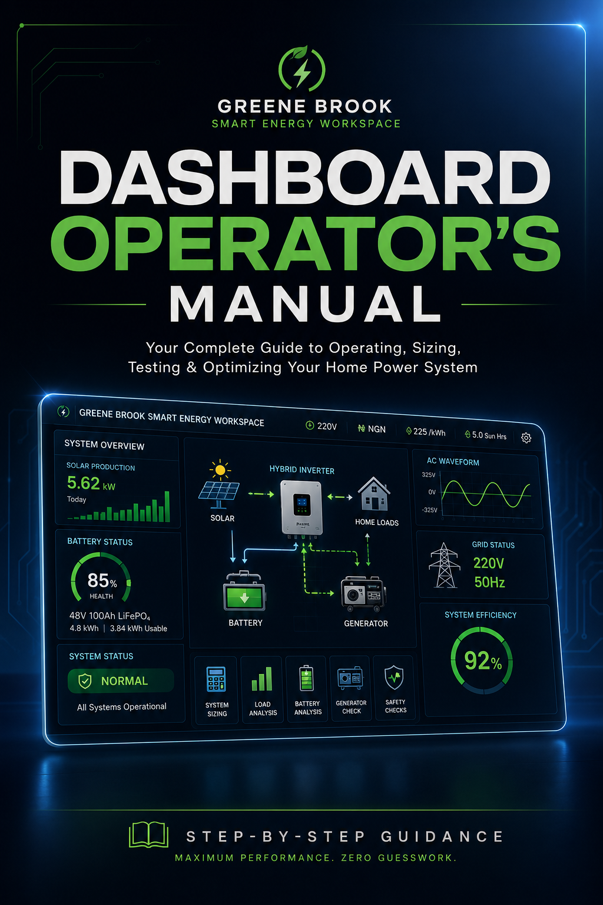
Greene Brook Smart Energy Master Dashboard: Complete Operational Manual
A Friendly, Step-by-Step Guide with Easy Examples, Everyday Analogies, and Simple Rules

Welcome to Your Simple Energy Workspace!
Imagine you are building a backup power system for your home, but you want to make sure it doesn't break, get ruined by cheap fake parts, or shut down when your water pump starts.
This manual is written like a friendly conversation. We will use simple stories—like glasses of soda, pushing stalled cars, and drinking milkshakes—to explain the real science of electricity. Whether you are a high school student or a grandparent, you will find it easy to follow along!

Section 1: Setting the Stage (The Header)
Before you type in your household appliances, you must tell the dashboard where you live in the world.

1.1 Voltage Standard (The Water Pressure Analogy)
- Where to click: The "Voltage" dropdown in the very top header.
- What to choose:
  - Select $220\text{ V}$ if you live in Europe, Africa, Nigeria, or the UK.
  - Select $110\text{ V}$ if you live in the US, Canada, or Japan.
- The Story Example:
  - Think of voltage like water pressure in a garden hose.
  - If you have low pressure ($110\text{ V}$), you must use a much thicker hose to get the same amount of water out.
  - If you have high pressure ($220\text{ V}$), the water flows more forcefully, so the wires can stay thinner without getting hot.
  - Our formula is:
- $$I = \frac{P}{V}$$
(Translation: Current/Heat ($I$) is equal to Power ($P$) divided by Voltage ($V$). Low voltage means high heat!)

1.2 Sun Hours & Money Settings
- Currency Selector: Choose your local money symbol ($\unicode{x20A6}$, $\$$, $\pounds$, $\in$, $\text{Rs}$).
- Tariff/kWh: Look at your last electricity bill and enter what the utility company charges you for one unit of power (e.g., $\unicode{x20A6}225$ or $\$0.15$).
- Sun Hours (The Bucket Example): Enter how many hours of strong, direct sunlight your roof gets daily.
  - The Story Example: Raw daylight might last 12 hours, but "Peak Sun Hours" is like having a giant funnel. Only during the middle of the day is the light strong enough to fill your battery "bucket" rapidly.
  - Tropical areas (Nigeria/Brazil): Enter $5.0\text{ to }6.0\text{ Hours}$.
  - Temperate areas (UK/Europe): Enter $3.0\text{ to }4.0\text{ Hours}$.

Section 2: Your Core Hardware (Left Column, Box 1)
This is where you tell the dashboard about the size of the "power engines" and "storage buckets" sitting in your garage.

2.1 Inverter vs. Generator (The Soda Glass Analogy)
Enter your inverter and generator continuous capacities in Kilovolt-Amperes ($\text{kVA}$).
[ kVA Rating ]
+----------------+
| ( \ ) ( \ ) | <--- The "Foam" (Inductive Wasted Power, kVAR)
|~~~~~~~~~~~~~~~~|
| Liquid Soda | <--- The "Real Work" (Active Power, kW)
| Liquid Soda |
+----------------+

- The Story Example: Imagine you order a glass of soda. The space inside the glass is the total capacity ($\text{kVA}$). The cold liquid is the actual power that does work ($\text{kW}$). The foam at the top is wasted energy ($\text{kVAR}$).
- The Hybrid Inverter: Features a Unity Power Factor ($PF = 1.0$). This is a glass with no foam! A $3.5\text{ kVA}$ inverter gives you exactly $3,500\text{ W}$ of actual, working liquid.
- The Fossil-Fuel Generator: Features an Inductive Power Factor ($PF = 0.8$). This is a glass with $20\%$ foam! A $3.5\text{ kVA}$ generator only gives you $2,800\text{ W}$ of actual working liquid:
$$kW = kVA \times PF$$$$\text{Generator: } 3.5\text{ kVA} \times 0.8 = 2.8\text{ kW } (2,800\text{ W})$$

2.2 Battery Storage (The Bank Account Analogy)
- The Story Example: Think of your battery like a savings account.
- Gel / Lead-Acid batteries have strict rules: if you have $\$100$ in the account, the bank locks your card the moment you spend $\$50$ (a $50\%$ Depth of Discharge limit). If you force it lower, you ruin the battery plates forever.
- Lithium ($\text{LiFePO}_4$) batteries are generous: they let you safely spend $\$80$ out of your $\$100$ (an $80\%$ Depth of Discharge limit) without hurting the battery.
- The dashboard calculates your total power reservoir automatically using:
$$\text{Storage Pool (Wh)} = V \times Ah$$
Example: A $48\text{ V}$ battery bank rated at $100\text{ Ah}$ holds:
$$48\text{ V} \times 100\text{ Ah} = 4,800\text{ Wh } (4.8\text{ kWh)}$$

2.3 DC Battery Wires (The Boba Straw Analogy)
- What to do: Select your wire thickness (from thin $16\text{ mm}^2$ up to heavy-duty $50\text{ mm}^2$) and length.
- The Story Example: Imagine drinking a thick, delicious milkshake through a tiny, thin coffee stirrer straw. Your cheeks collapse because it is too hard to pull the liquid through. Thin wires are like that coffee stirrer straw. If your inverter tries to pull huge startup power from the battery through thin wires, the inverter "starves," panics, and shuts down with a "Low Battery" alarm—even though the battery is completely full! Always choose thick, pure copper wires ($\ge 35\text{ mm}^2$) kept short ($\le 1.5\text{ meters}$).

Section 3: The Sizing Checklist (Left Column, Box 2)
This is a live checklist of everything you want to turn on inside your house.

3.1 Understanding "Running Watts" vs "Surge Watts"
- Running Watts: The steady power an appliance uses while running normally.
- Surge Multiplier: The temporary, violent burst of power a motor needs just to turn on.

3.2 The Sumo Pump Surge (The Stalled Car Analogy)
+-------------------------------------------------------------+
| THE WATER PUMP |
| |
| [Dead Stop] =======> [PUSH HARD! 5x Surge] =======> [Running]
| Needs 3,750W To break friction Needs 750W |
+-------------------------------------------------------------+

- The Story Example: Imagine you are trying to push a heavy, stalled car. It takes five people pushing with all their might just to break the static friction and get the car rolling from a dead stop. This is the $5\times$ startup surge. Once the car is rolling down the road, however, one single person can easily keep pushing it along with a single hand. This is the $750\text{ W}$ running power.
- The Calculation: The dashboard automatically calculates this for your Sumo Water Pump:
$$750\text{ W (Running)} \times 5\text{ (Surge Multiplier)} = 3,750\text{ W (Starting Surge)}$$
Your inverter must be big enough to survive that brief, powerful $3,750\text{ W}$ push, even if it only lasts for half a second!

Section 4: The Smart AC Sizing Engine (Left Column, Box 3)
Air conditioners are the heaviest loads in most houses. Look at the metal sticker on your outdoor AC unit to find these values.

4.1 Simple Manual Entry
- Power Input (Running): This is what the AC draws on a mild, comfortable day (e.g., $1,180\text{ W}$).
- Rated Power Input (Extreme): This is what the AC draws on a boiling-hot summer afternoon when the outdoor compressor is working under intense stress (e.g., $1,720\text{ W}$).
- LRA (Locked Rotor Amps): This is the ultimate "startup push" current.
  - If your sticker has an LRA number: Enter it (e.g., $9.0\text{ A}$). The dashboard automatically calculates the true startup surge.
  - If you can't find it: Select your technology type:
    - Fixed-Speed Inductive: A classic, older AC. It starts with a violent $4\times\text{ to }5\times$ power surge.
    - Variable Inverter: A modern, smart AC. It starts with a soft, gentle crawl ($1.5\times$ surge), meaning it won't crash your system!

4.2 Photo Scanner Mode
If you hate typing numbers, toggle the tab to "Photo Label Scanner".
- Click "Load Label IMG_20260508_173411.jpg" to see how the computer reads a real sticker.
- Click "Scan Label". The built-in simulator will automatically read the image, find the secret technical specs, and update your checklist without you having to touch a thing!

Section 5: The System Verdict (Right Column, Top Box)
As you check and uncheck appliances, the dashboard acts like a digital referee, instantly showing one of four color-coded statuses.

5.1 STATE A: "SYSTEM SECURE" (Emerald Green)
- What it means: Congratulations! Your running loads and starting surges fit perfectly inside your inverter, generator, and cable limits.
- High School Metric: You have plenty of "headroom" (extra space) to turn on more devices.

5.2 STATE B: "OVERLOAD TRIPPED" (Crimson Red)
- What it means: You turned on too many things at once! Your steady running loads exceed your inverter's continuous capacity limit.
- How to fix it: Simply uncheck heavy items (like the microwave or washing machine) until the light turns green again.

5.3 STATE C: "SURGE FAILURE" (Amber Yellow)
- What it means: Your devices can run steadily, but if they all start up at the same moment (e.g., your refrigerator cycles on while the water pump is running), the sudden startup surge will crash your inverter.
- How to fix it: Install a "soft-starter" on your pump, or stagger your appliance usage so you don't turn them on at the exact same second.

5.4 STATE D: "CAPACITOR STARVATION" (Amber Yellow)
- What it means: You have a heavy motorized load, but your battery wires are too thin. The inverter is starving for power during starting phases.
- How to fix it: Swap your battery cables for thick, pure-copper $35\text{ mm}^2\text{ to }50\text{ mm}^2$ lines.

Section 6: Sizing & Diagnostics Lab (Right Column, Tabs)
Click these tabs to open advanced troubleshooting tools.

6.1 Sizing Slides Tab
This is a virtual classroom deck containing 20 bite-sized lessons. Use the "Next" and "Prev" buttons to read slide-by-slide tips on everything from lightning surge protectors to grounding safety.

6.2 Diagnostics Lab Tab (The Anti-Scam Shield)
[ THE BATTERY WEIGHT AUDIT ]
Ah: 100Ah | Volts: 48V | Real Weight: 28 kg
============================================
>> [ RESULT: CRIMSON WARNING - UNDERWEIGHT! ]
>> Scam Detected: Hollow cells or sandbags.

1. The Fake Battery Weight Audit (The Box of Chocolates Analogy)
- The Story Example: Imagine you buy a premium box of chocolates. If the box is supposed to hold 100 large pieces, but when you pick it up it feels as light as a feather, you know you've been cheated. Some dishonest dealers pack cheap battery cases with concrete, sandbags, or heavy steel plates to trick hanging scales, or sell small batteries inside oversized plastic boxes.
- The Physical Test: A genuine Lithium ($\text{LiFePO}_4$) battery block rated at $48\text{ V}\ 100\text{ Ah}$ must weigh between $38\text{ kg}$ and $45\text{ kg}$ due to the inescapable laws of chemical density.
- How to use: Enter your battery's details and weigh it on a bathroom scale. If it weighs less than $35\text{ kg}$ or more than $55\text{ kg}$, the dashboard triggers a crimson scam warning!

2. Voltage Sag & Internal Resistance (The Clogged Pipe Analogy)
- The Story Example: Imagine turning on your garden faucet. When the nozzle is closed, the static water pressure looks high and perfect. But the second you open the nozzle, if the water pressure drops to a tiny, weak trickle, you know there is a severe rust clog inside the pipe.
- The Test: Measure your battery voltage when everything in the house is turned off (Open Circuit Voltage, $V_{oc}$). Then, turn on a heavy appliance (like your AC) and write down the new voltage ($V_{load}$) and current ($I$). The dashboard calculates the internal "clog resistance" ($R_{\text{internal}}$):
$$R_{\text{internal}} = \frac{V_{oc} - V_{load}}{I} \times 1,000$$
  - Under $80\ \text{m}\Omega$: Excellent! Your battery "pipes" are clean and healthy.
  - Over $150\ \text{m}\Omega$: Severe decay! Your battery cells are old, clogged, and struggling to pass current.

6.3 Signal Waves Tab
- Pure Inverter Wave: Shows a beautiful, clean, smooth rolling wave ($< 3\%$ distortion). Your smart electronics will run perfectly.
- Grid Utility Wave: Displays minor bumps ($3\%\text{ to }5\%$ distortion) representing standard grid noise.
- Generator Wave: Displays a jagged, spikey, unstable red scribble ($\approx 18\%$ distortion). If this wave is too wild, your sensitive hybrid inverter will click its relays and refuse to accept the power to protect your home.

6.4 Solar PV Sizing & Dust Harvest Loss
- Min Panel Qty: Displays how many solar panels you need on your roof to fully recharge your battery bank every single day.
- The Dust Derating Engine (The Dirty Window Analogy):
  - The Story Example: If your windows are covered in thick harmattan dust or pollen, very little light enters your living room. Similarly, dust, bird droppings, and intense solar heat can cut your solar panel output by up to $40\%$.
  - How to use: Enter the number of panels on your roof and adjust the dust loss percentage. The dashboard will instantly tell you if your dirty panels are still generating enough electricity to run your household, or if you need to buy extra panels or clean them!

6.5 Transfer Portal (Laminated Safety Sheets)
- How to use: Type in your house address and click "Generate Hand-Over Script".
- Why it matters: If you ever sell your home or go on vacation, your family members or the new homeowner might not know how to run a solar system. This feature generates a beautiful, simple, plain-English instruction sheet that you can print out, laminate, and tape next to your breaker panel. It tells them exactly which hours are safe to run water pumps and how to turn the system off in an emergency!

Section 7: Quick Troubleshooting Cheat Sheet
The Symptom | What is Actually Happening | The Simple Solution
The Inverter instantly shuts down when the water pump starts. | The pump is demanding a massive starting surge ($5\times$) that is choking the inverter. | Install an inline soft-starter on your pump, or buy an inverter with a larger peak surge rating.
"Low Battery" alarm beep under heavy load, even though the battery was at $100\%$. | Capacitor Starvation. The battery wires are too thin or too long, like trying to drink a thick shake through a coffee straw. | Replace your wires with thick, heavy-duty $35\text{ mm}^2$ or $50\text{ mm}^2$ pure copper cables. Keep them under $1.5\text{ meters}$.
The Inverter keeps clicking back and forth and rejects the generator. | The generator's engine is shaking and spinning unevenly under load, creating an unstable electrical wave ($>15\%\ \text{THD}$). | Access your inverter’s configuration menu and change the AC Input setting from "UPS Mode" to "Generator Mode" or "Wide Mode".
The battery runs out of juice much quicker than expected. | Either your battery is underweight (counterfeit sand/concrete trick), or your depth of discharge limits are set wrong. | Run the Weight Audit and Voltage Sag Test in the Diagnostics Lab to check for fake cells.
Operational Manual compiled by the Greene Brook Smart Energy Workspace Division.

